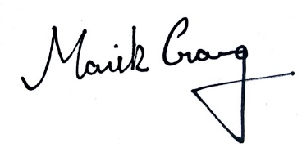

Manik Garg

CLOUD 101

24th AUGUST 2019

**Vitesh Sethi**